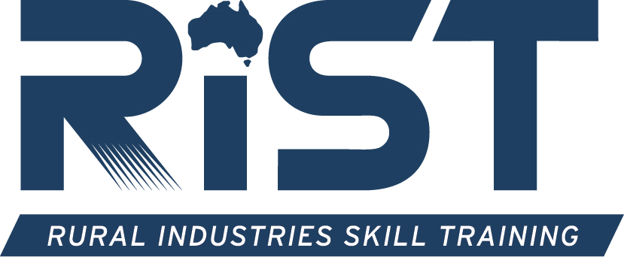

Application to deliver the RIST National Programs
Lifetime Ewe Management (LTEM), Weaners for Profit (WFP), Heifers for Profit (HFP)

Program(s) you are applying to deliver – please tick
☐ Lifetime Ewe Management (LTEM)
☐ Weaners for Profit (WFP)
☐ Heifers for Profit (HFP)
☐ All three programs (LTEM, WFP and HFP)

General Information about RIST:
Rural Industries Skill Training Centre Inc. (RIST) is a Registered Training Organisation (RTO No. 4198), founded in 1992 by a group of farmers and industry representatives dedicated to strengthening the Australian wool and agricultural industries through excellence in training and education. Today, RIST is recognised as one of Australia’s leading independent agricultural colleges, providing vocational education and training across accredited and non-accredited pathways.
Based in the heart of Victoria’s Western District at Hamilton, RIST is a local agricultural college with national reach, delivering training onsite, online and on farm across Australia. Our courses range from the Certificate II in Agriculture through to the Diploma of Agriculture, short courses and our national on-farm programs – Lifetime Ewe Management, Weaners for Profit and Heifers for Profit – which build the skills and knowledge of producers to increase whole-farm profitability.
With a philosophy of developing critical thinking skills that produce adaptable, resilient, resourceful and technologically competent students, and a focus on innovation, sustainability and industry collaboration, RIST delivers outcomes to students and industry alike through partnerships, innovative training and a thorough understanding of market opportunities and needs.

Becoming a RIST National Programs Trainer:
To ensure the quality of the LTEM, WFP and HFP courses being delivered, the applicant must meet the minimum requirements set out herein before their application will be further considered. There is no guarantee that by completing this application you will be offered a contract to deliver the course(s) selected.
When completing the application form you will also need to provide verified copies of qualifications that relate to your area of expertise (in delivery) and a copy of your CV.
Check List:
☐ You MUST provide a copy of your CV
☐ You MUST provide verified copies of your qualification(s)
☐ You MUST of read, understood and agreed with the roles and key performance criteria
outlined in the Position Description/s for the Trainer role you are applying for in the application
Copies of qualifications need to be verified in original handwriting by either a JP or Police
Officer

Personal Details
Name in full:
Home address:
Date of Birth: | Female ☐ Male ☐ Unspecified ☐
Personal contact details: | Mobile:  Phone:  Email:

Current Employment
Employment Company:
Work address:
Contact Details: | Mobile:  Phone:  Email:
Employment Status: | ☐ Owner ☐ Full time employee ☐ Part time employee  ☐ Casual/contract

Qualifications
Minimum requirement: | A minimum requirement is a Bachelor qualification in Agriculture, Animal Science or equivalent.
Qualification details: | Qualification:  University attained:  Date achieved:  Qualification:  University attained:  Date achieved:

Certificate IV in Training and Assessment
It is recommended, but not mandatory, to attain a Certificate IV in Training and Assessment.
Do you have a Certificate IV in Training and Assessment: YES ☐ NO ☐
Qualification details: | Qualification:  RTO attained:  Date achieved:

Experience in Agriculture
A minimum requirement of 5 years (post graduating) demonstrated on-farm consulting experience relevant to the program(s) applied for – the sheep and wool industry (LTEM) and/or cattle, heifer and weaner condition, nutrition and reproduction (WFP/HFP) – providing strategic on-farm advice to enhance sustainability and profitability.
……………………………………………………………………………………………………………………
……………………………………………………………………………………………………………………
……………………………………………………………………………………………………………………

……………………………………………………………………………………………………………………
……………………………………………………………………………………………………………………
……………………………………………………………………………………………………………………
……………………………………………………………………………………………………………………
……………………………………………………………………………………………………………………
……………………………………………………………………………………………………………………

Experience in Agriculture – Livestock Nutrition
Demonstrated understanding of the nutritional requirements of the livestock relevant to the program(s) applied for (ewes and lambs, weaners, and/or heifers and cows).
……………………………………………………………………………………………………………………
……………………………………………………………………………………………………………………
……………………………………………………………………………………………………………………
……………………………………………………………………………………………………………………
……………………………………………………………………………………………………………………

Experience in Delivering Training
Demonstrated experience in personally delivering agriculture training in a group format with various generations, with the outcome of influencing change.
……………………………………………………………………………………………………………………

……………………………………………………………………………………………………………………
……………………………………………………………………………………………………………………
……………………………………………………………………………………………………………………

How many groups can you actually form and start delivering to, in this year?
(this question is not based on how many you would like to service per year)
1 Group ☐ 2–3 Groups ☐ 4+ Groups ☐

Current network connections
It is a mandatory requirement that you develop your own LTEM, WFP and/or HFP groups; please list your network connections that have clients who may be interested in undertaking the course(s) and forming a group.
……………………………………………………………………………………………………………………
……………………………………………………………………………………………………………………
……………………………………………………………………………………………………………………
……………………………………………………………………………………………………………………
……………………………………………………………………………………………………………………
……………………………………………………………………………………………………………………

Mentorship Program (LTEM applicants)
Upon completing the application, are you willing to undertake the following:
Step 1:
- 12 month mentorship program with a current LTEM Trainer/Mentor;
- Commit to participating in an LTEM group at your own time and expense with your allocated mentor;
- Follow the advice and guidance of your mentor.
Step 2:
- Upon successful completion of the 12-month mentorship program and recommendation from your mentor, establish your own LTEM groups to commence delivery within 12 months.
YES ☐ NO ☐
Signed: ………………………………………………………… Date: ………………………………

Referees
Please provide 3 referees to validate your knowledge, experience and skills in the agriculture industry and training (by providing these referees, you give consent to RIST to contact):
Referee Name:
Position and Employer:
Relationship to yourself:
Phone Number:

Referee Name:
Position and Employer:
Relationship to yourself:
Phone Number:

Referee Name:
Position and Employer:
Relationship to yourself:
Phone Number:

Application Evaluation
Your application will be evaluated based on the following criteria set out below.
- Geographical area of delivery and RIST’s current trainer resources and availability
- Demonstrated experience and knowledge in the sheep and wool and/or cattle industry (relevant to the program(s) applied for)
- Demonstrated experience and knowledge in group training and delivery
- Networking connections
- Qualifications
- Quality of references

National Programs Contact Details:
Natasha Wilkinson
National Programs Manager
Rural Industries Skill Training (RIST)
915 Mt Napier Road
HAMILTON VIC 3300
Email: nwilkinson@rist.edu.au Phone: 03 5573 0922 / 0407 730 943

Annexures
Please read the Positions Descriptions that are uploaded in the web for a deeper understanding of the role.
Annexure 1 – Lifetime Ewe Management Trainer – Position Description
Annexure 2 – Weaners for Profit Trainer – Position Description
Annexure 3 – Heifers for Profit Trainer – Position Description

